**A picture containing clipart

Description generated with very high confidence**

SAVING CHANGES TO A DOCKER CONTAINER

DevOps Certification Training

[**support@intellipaat.com**](mailto:support@intellipaat.com)

**+91-7022374614**

**US: 1-800-216-8930(Toll Free)**

**SAVING CHANGES TO A DOCKER CONTAINER**

**Step 1:** Pull the docker container using the command:

$ docker pull ubuntu

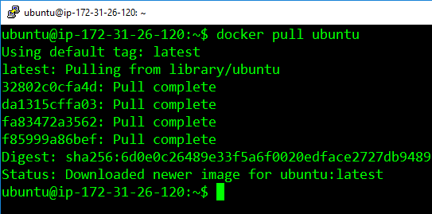

**Step 2:** Run the container using the commands

$ docker run –it –d ubuntu

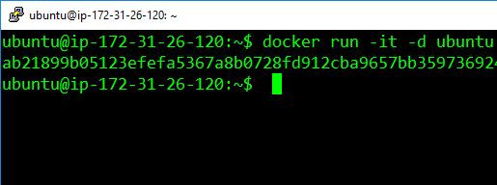

**Step 3:** Access the container using the command:

$ docker exec –it <container-id> bash

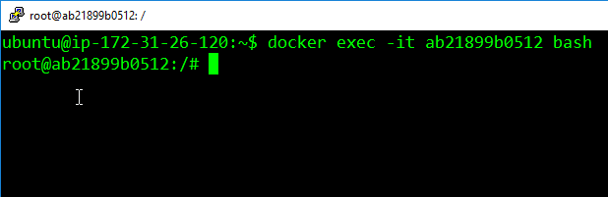

**Step 4:** Install apache2 on this container, using the following commands

$ apt-get update

$ apt-get install apache2

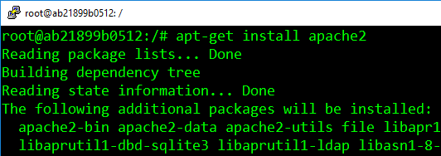

**Step 5:** Exit the container, and save the container using this command. The saved container will be converted into an image with the name specified is

$ docker commit <container-id> <username>/<container-name>

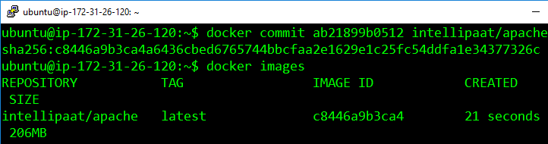

The username must match with the username which you created on dockerhub. The container-name name can be anything.